EMBEDDED SYSTEMS LAB
FAROOQ AHMAD EXPERIMENT # 10
17L-4407 LAB REPORT # 10
EL-7B

PULSE WIDTH MODULATION

INTRODUCTION
In this lab session, we were introduced to pulse width modulation using tm4c123gh6pm. Pulse-width modulation (PWM) is a modulation process or technique used in most communication systems for encoding the amplitude of a signal right into a pulse width or duration of another signal, usually a carrier signal, for transmission. The speed of the motor depends on three factors: (a) load, (b) voltage, and (c) current. For a given fixed load we can maintain a steady speed by using a method called pulse width modulation (PWM).
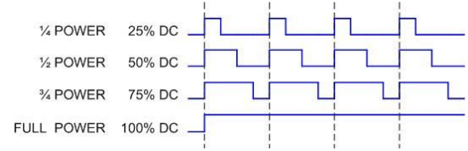
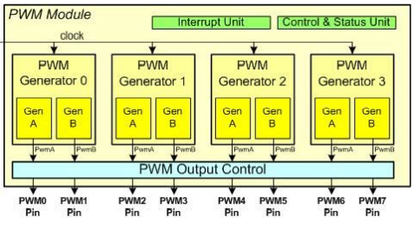
1. There are two PWM modules, PWM0 and PWM1.
2. Each PWM module has four Generators.
3. Each Generator has a Counter (Timer).
4. Each Generator has two Compare registers CMPA and CMPB.
5. Each Generator has two output pins, which means there are a total of 8 PWM pins per module.
6. The Counter of the Generator can be programmed to count-up or count-up/down.
7. As the Counter counts, it may change the output pin when the counter value matches the Compare registers, reaches zero, or is reloaded. The options for output pin change are toggle, driven LOW, or driven High.

OBJECTIVE
The course learning objective of this lab session was to Learn to configure PWM module of TM4C and to learn generating tones of different frequencies using PWM.

PROCEDURE
Programming PWM Module of TM4C
There are two on chip PWM modules on TM4C: PWM0 and PWM1. Each module has four generators. Each generator has a counter (timer). Each generator has two compare registers CMPA and CMPB. Each generator has two output pins, which means there are total of 8 PWM pins per module. The counter of generator can be programmed as up or down counter.
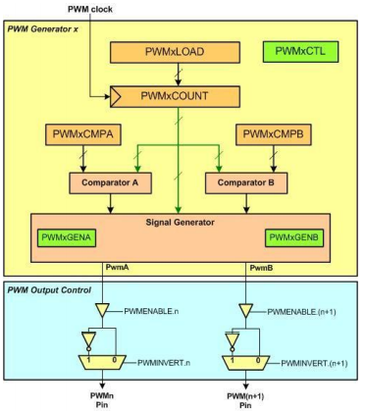
Configuring GPIO pin for PWM
In using PWM, we must configure the GPIO pins for PWM output. In this regard, it is same as all other peripherals.
The steps are as follow:
1. Enable the clock to GPIO pin by using RCGCGPIO.
2. Set the GPIOAFSEL (GPIO alternate function) for PWM output pins.
3. Enable digital pins in the GPIODEN (GPIO Digital enable) register.
4. Assign the PWM signals to specific pins using GPIOCTL register. See Tables 11-4 through 11-7.
Configuring PWM generator to create pulses
After the GPIO configuration, we need to take the following steps to configure the PWM:
1. Disable the generator using PWMxCTL register.
2. Configure PWMxGENA (or PWMxGENB).
3. Load the value into PWMxLOAD register to set the desired output frequency.
4. Load the value into PWMxCMPA (or PWMxCMPB) register to set the desired duty cycle.
5. Start the PWM generator using PWMxCTL.
6. Configure PWMxENABLE register to direct the PWMx to output pin
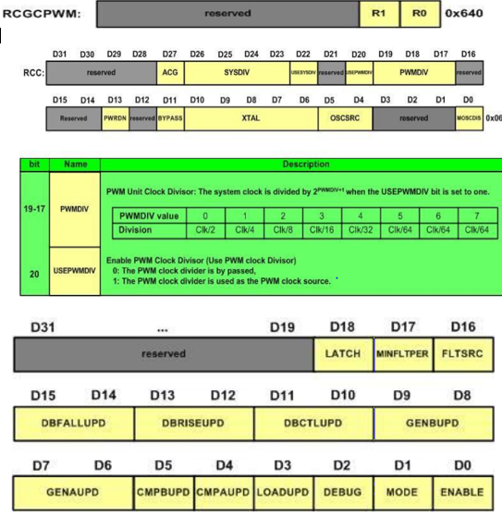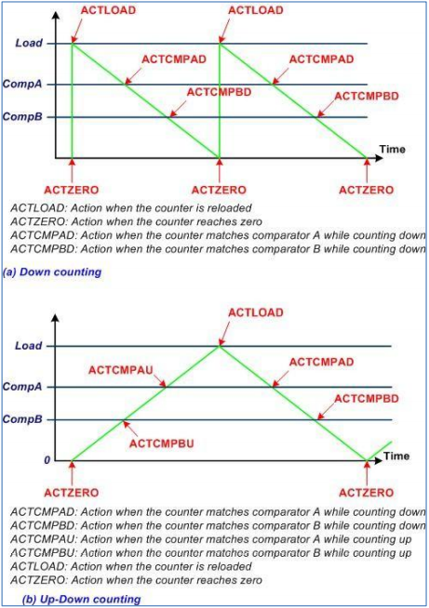

ISSUES
There were no issues.

CONCLUSION
This experiment was performed successfully. In this lab session, it was learnt how to configure the pulse width modulation (pwm) module of tm4c123gh6pm tiva launchpad and with the use of it how to control the speed of dc motor. Pulse Width Modulation allows to generate a wave of fixed frequency but of varying duty cycle. The waveforms that are high for H cycles and low for L cycles. The system is designed in such a way that H+L is constant (meaning the frequency is fixed). The duty cycle is defined as the fraction of time the signal is high: Hence, duty cycle varies from 0 to 1. We interface this digital output wave to an external actuator (like a DC motor), such that power is applied to the motor when the signal is high, and no power is applied when the signal is low. We purposely select a frequency high enough so the DC motor does not start/stop with each individual pulse, but rather responds to the overall average value of the wave. The average value of a PWM signal is linearly related to its duty cycle and is independent of its frequency.

APPLICATIONS
Applications of Pulse Width Modulation:
- In modern days, Pulse Width Modulation technique is used to control the speed of the motors in Industries.
- Pulse Width Modulation is used for dimming light.
- PWM is used to control the electrical power.
- PWM is used in communication system also.
- PWM is used in Audio system.
- In modern Inverters, the PWM is used.
- Using the PWM technique and the switching mechanism we can control analog signals using the digital signal.

POST LAB
#include <stdint.h>
#include "inc/tm4c123gh6pm.h"
#include <stdio.h>

int main(void)
{
void delayMs(int n);
int x = 15999;

/* Enable Peripheral Clocks */
SYSCTL_RCGCPWM_R |= 2; /* enable clock to PWM1 */
SYSCTL_RCGCGPIO_R |= 0x20; /* enable clock to PORTF */
SYSCTL_RCC_R &= ~0x00100000; /* no pre-divide for PWM clock */

/* Enable port PF3 for PWM1 M1PWM7 */
GPIO_PORTF_AFSEL_R = 8; /* PF3 uses alternate function */
GPIO_PORTF_PCTL_R &= ~0x0000F000; /* make PF3 PWM output pin */
GPIO_PORTF_PCTL_R |= 0x00005000;
GPIO_PORTF_DEN_R |= 8; /* pin digital */

PWM1_3_CTL_R = 0; /* stop counter */
PWM1_3_GENB_R = 0x0000008C; /* M1PWM7 output set when reload, */
/* clear when match PWMCMPA */
PWM1_3_LOAD_R = 16000;
PWM1_3_CMPA_R = 15999;
PWM1_3_CTL_R = 1; /* start timer */
PWM1_ENABLE_R = 0x80; /* start PWM1 ch7 */

for(;;)
{
x = x - 100;
if (x <= 0) x = 16000;
PWM1_3_CMPA_R = x;
delayMs(20);
}
}

/* delay n milliseconds (16 MHz CPU clock) */
void delayMs(int n)
{
int32_t i, j;
for(i = 0 ; i < n; i++)
for(j = 0; j < 3180; j++)
{} /* do nothing for 1 ms */
}

